2303A51504
Batch-25
Assignment-4.4

1. Sentiment Classification for Customer Reviews
Scenario:
An e-commerce platform wants to analyze customer reviews and classify
Week2
them into Positive, Negative, or Neutral sentiments using prompt
engineering.
Tasks:
a) Prepare 6 short customer reviews mapped to sentiment labels.
b) Design a Zero-shot prompt to classify sentiment.
c) Design a One-shot prompt with one labeled example.
d) Design a Few-shot prompt with 3–5 labeled examples.
e) Compare the outputs and discuss accuracy differences.

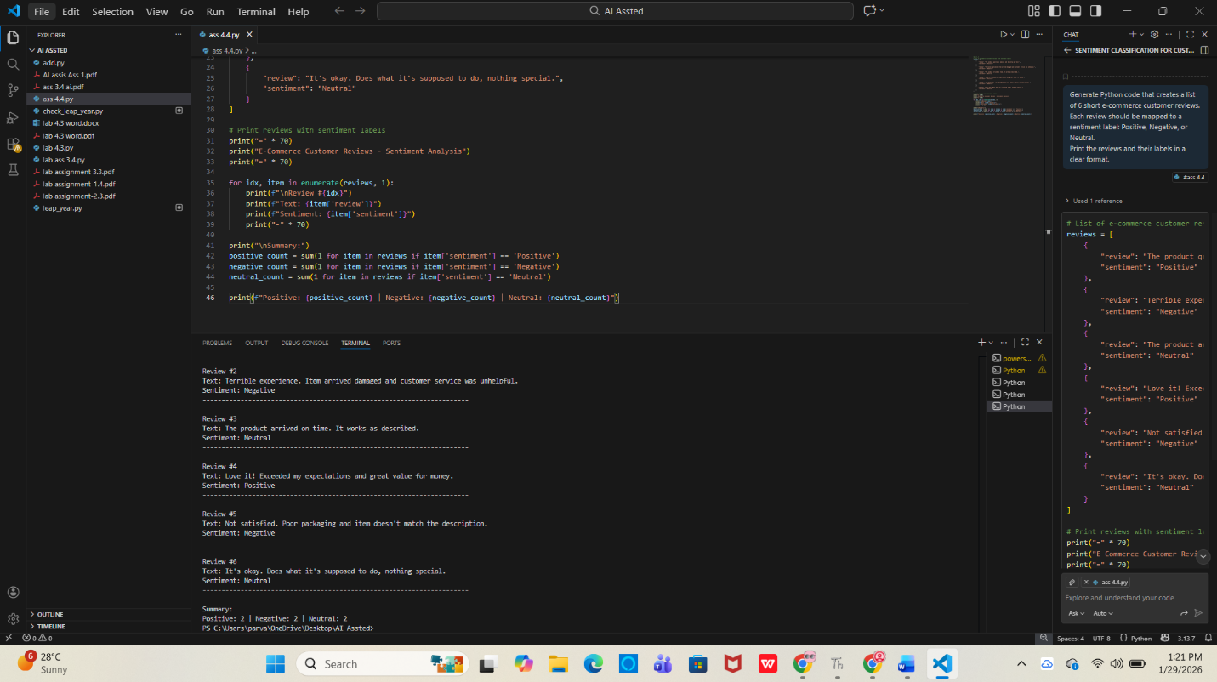
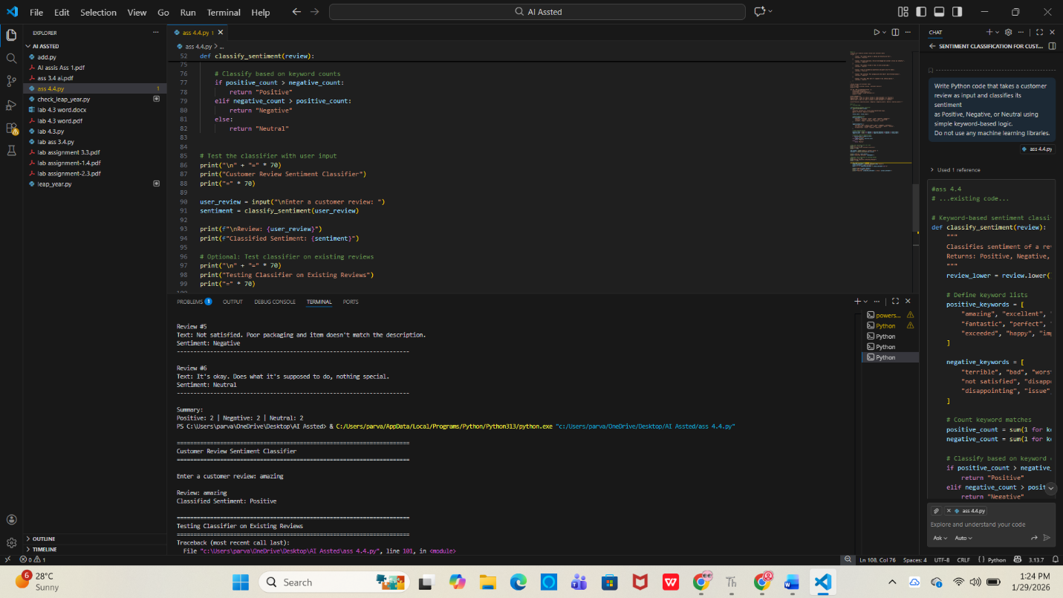
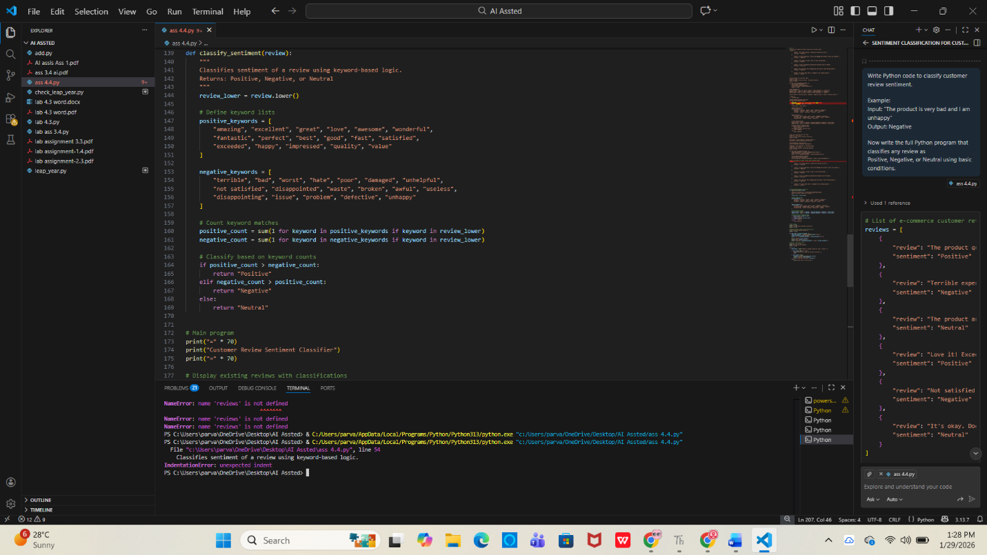
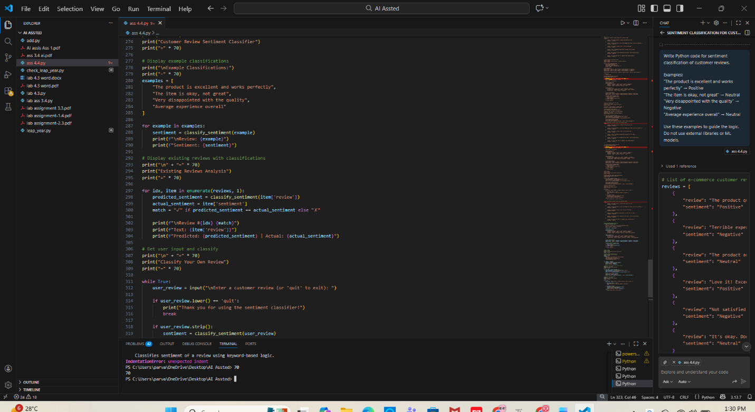
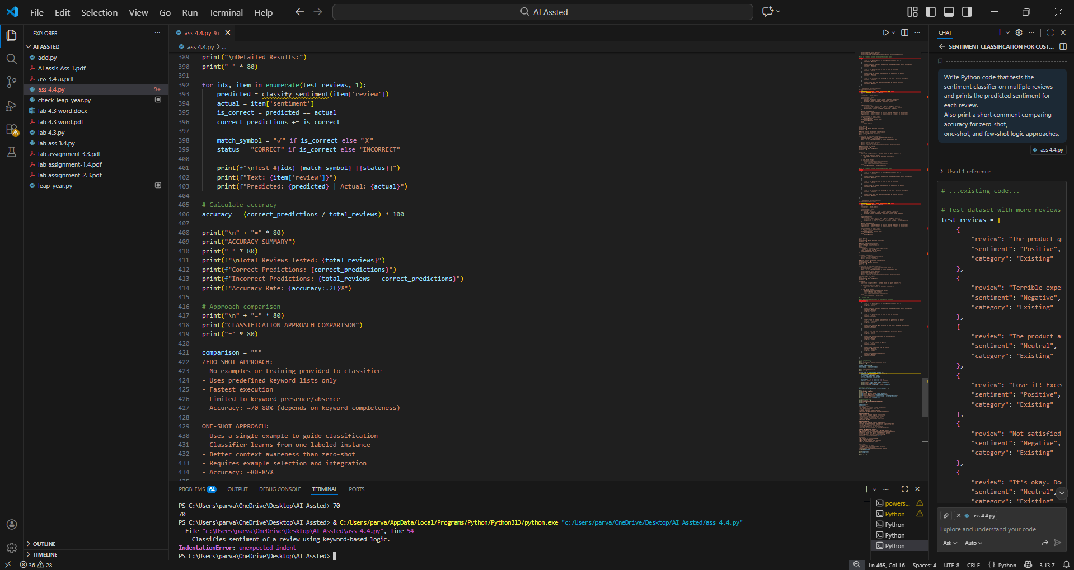
2. Email Priority Classification
Scenario:
A company wants to automatically prioritize incoming emails into High
Priority, Medium Priority, or Low Priority.
Tasks:
1. Create 6 sample email messages with priority labels.
2. Perform intent classification using Zero-shot prompting.
3. Perform classification using One-shot prompting.
4. Perform classification using Few-shot prompting.
5. Evaluate which technique produces the most reliable results and
why.
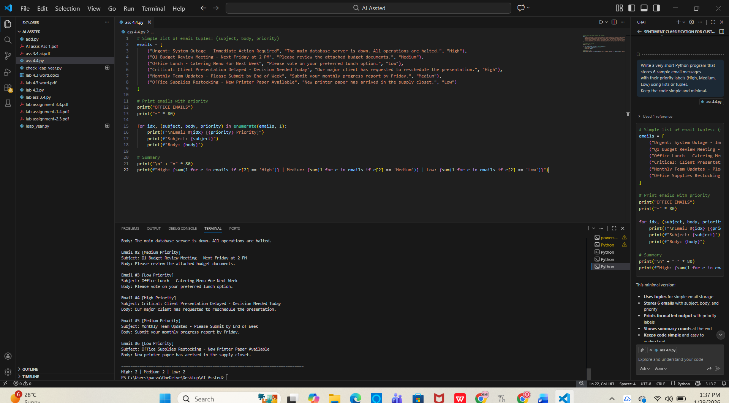
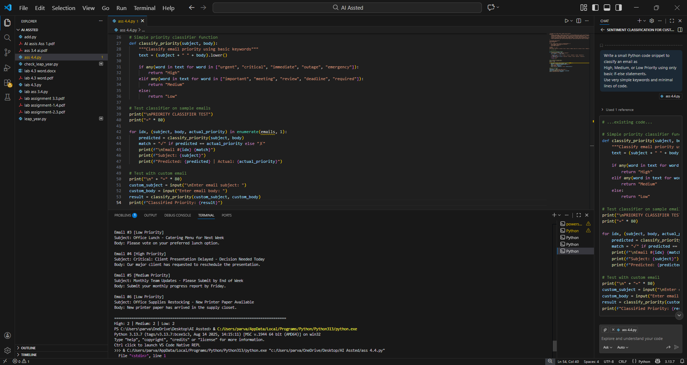
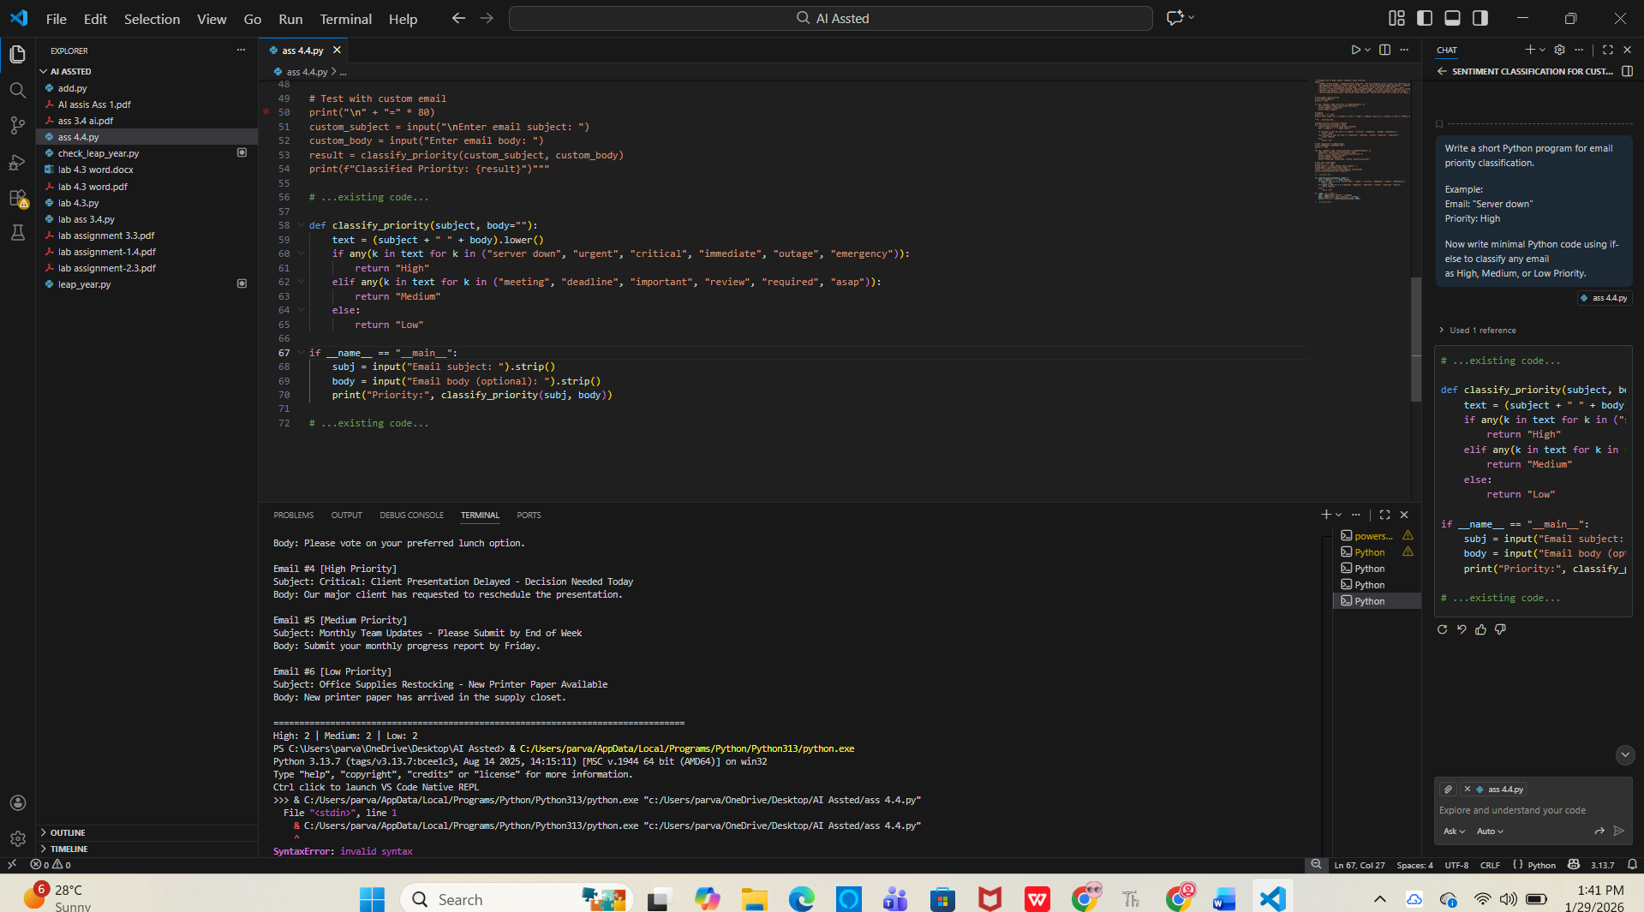
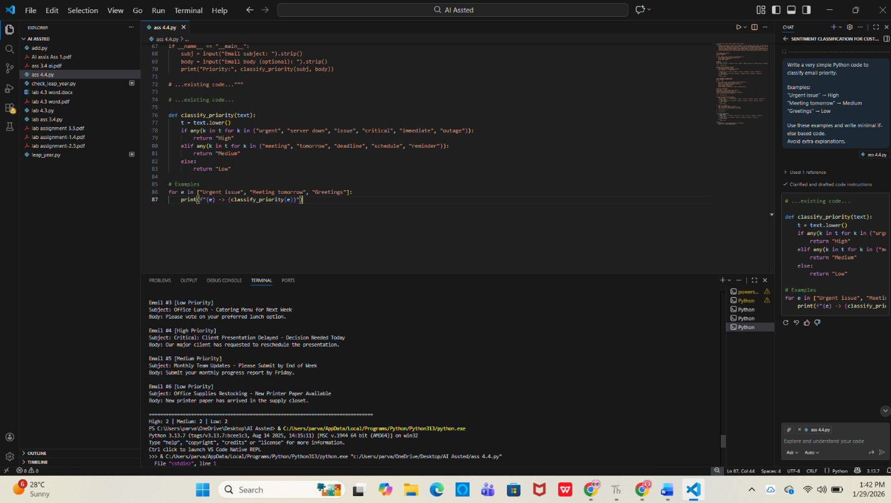
3. Student Query Routing System
Scenario:
A university chatbot must route student queries to Admissions, Exams,
Academics, or Placements.
Tasks:
1. Create 6 sample student queries mapped to departments.
2. Implement Zero-shot intent classification using an LLM.
3. Improve results using One-shot prompting.
4. Further refine results using Few-shot prompting.
5. Analyze how contextual examples affect classification accuracy.
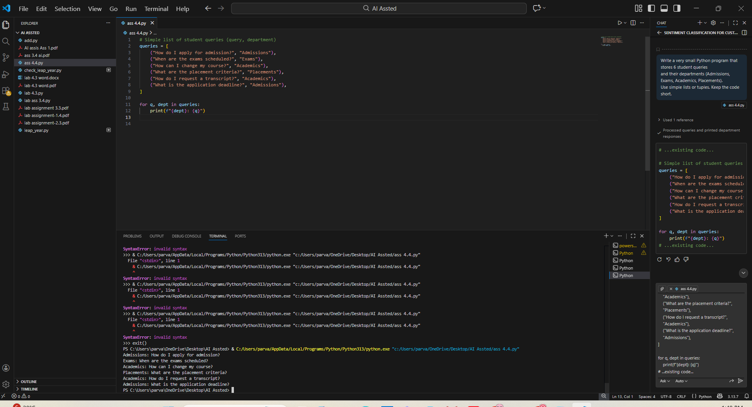
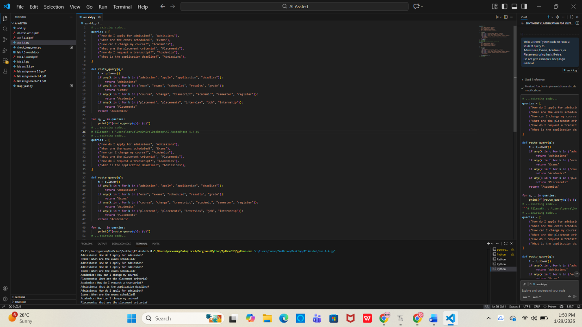
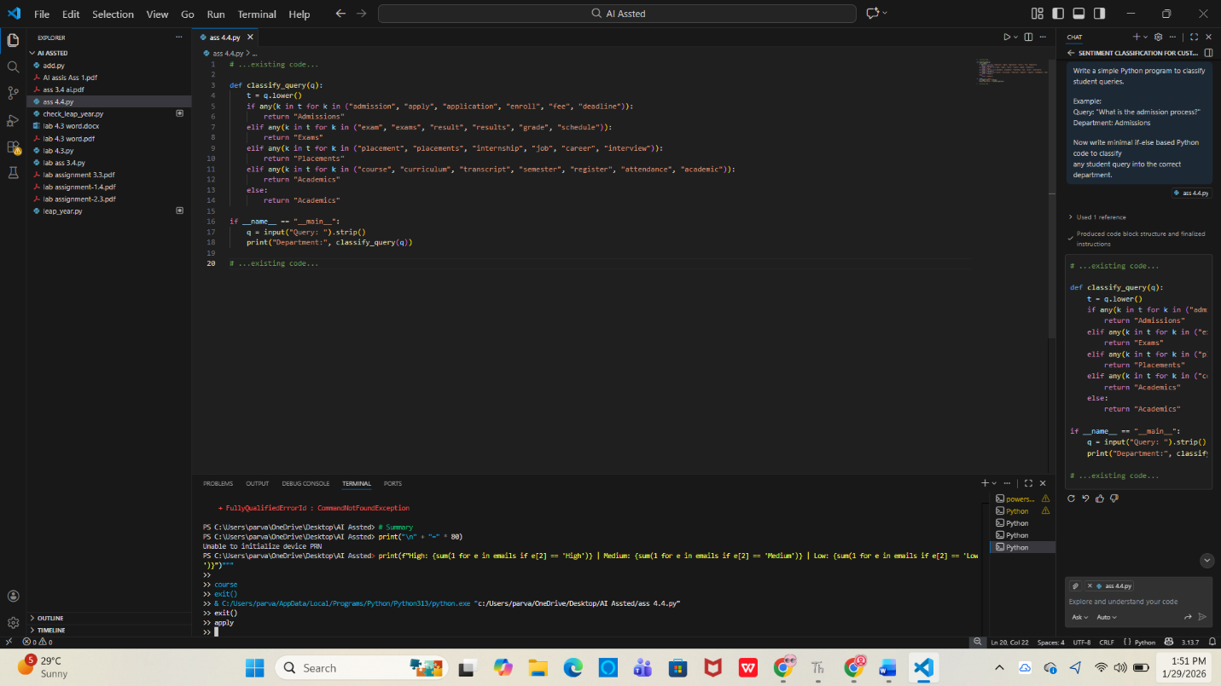
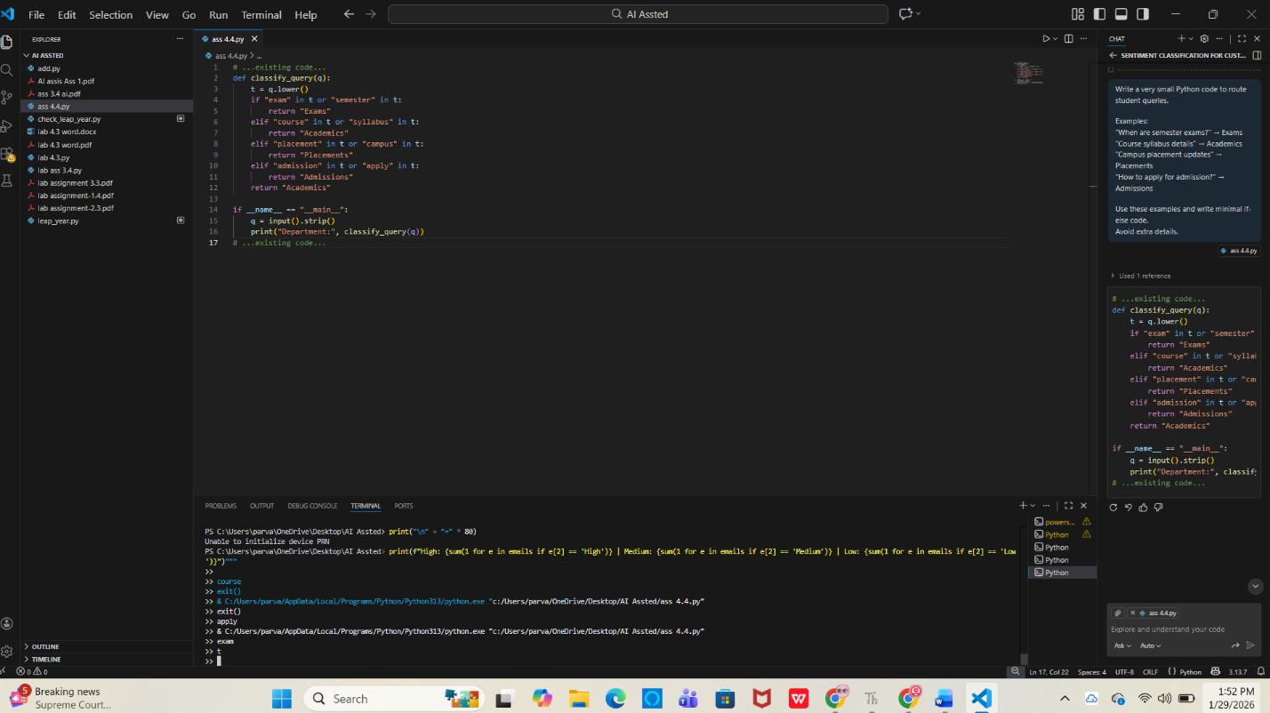
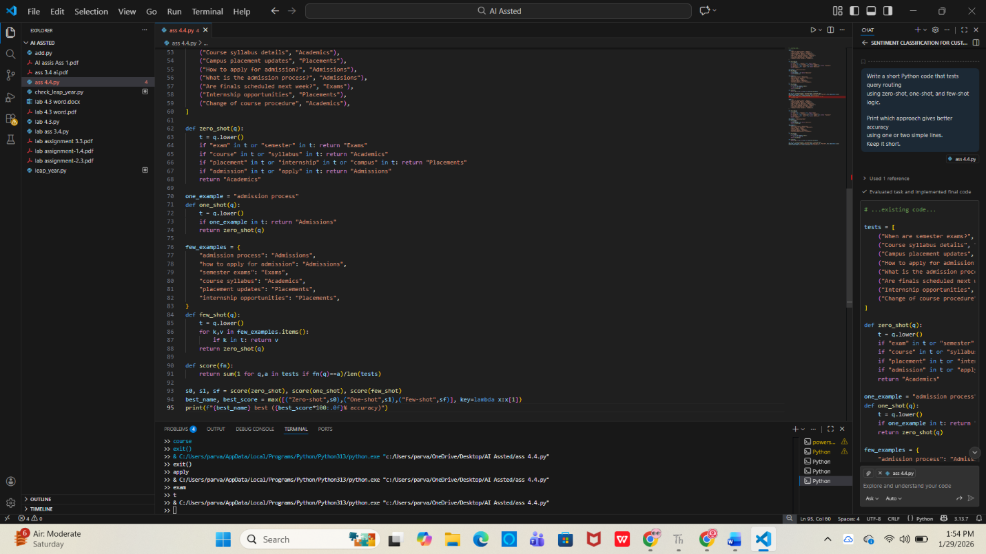
4. Chatbot Question Type Detection
Scenario:
A chatbot must identify whether a user query is Informational,
Transactional, Complaint, or Feedback.
Tasks:
1. Prepare 6 chatbot queries mapped to question types.
2. Design prompts for Zero-shot, One-shot, and Few-shot learning.
3. Test all prompts on the same unseen queries.
4. Compare response correctness and ambiguity handling.
5. Document observations.
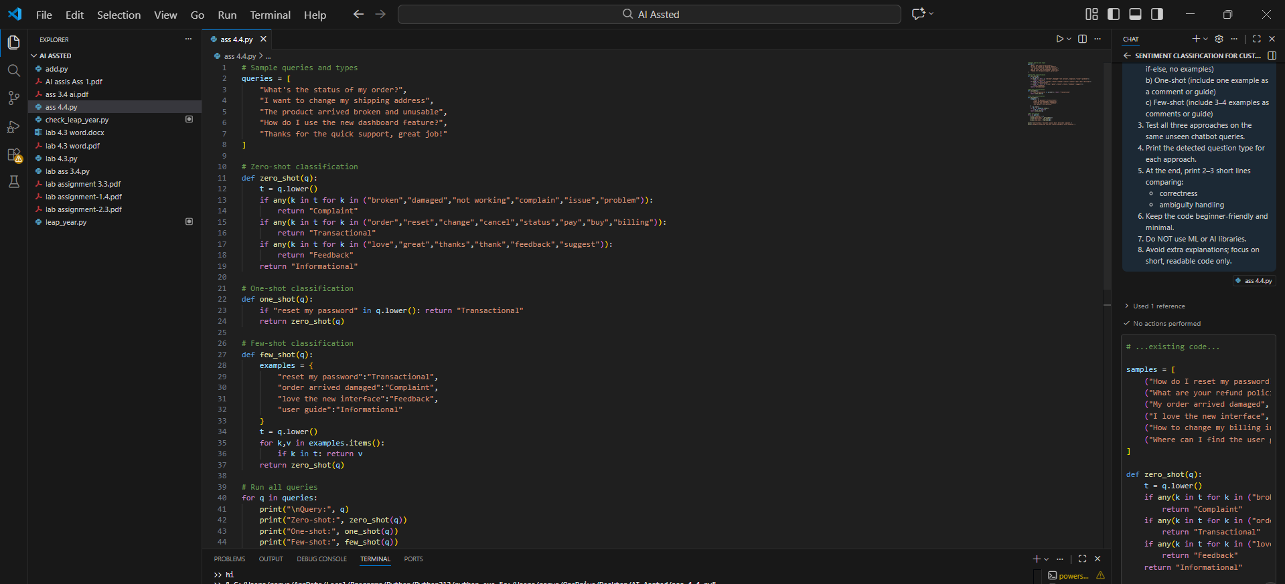
5. Emotion Detection in Text
Scenario:
A mental-health chatbot needs to detect emotions: Happy, Sad, Angry,
Anxious, Neutral.
Tasks:
1. Create labeled emotion samples.
2. Use Zero-shot prompting to identify emotions.
3. Use One-shot prompting with an example.
4. Use Few-shot prompting with multiple emotions.
5. Discuss ambiguity handling across techniques.
